Project Features: Digital Input, Analog Input and PWM Output.
Program an Arduino board to accept two digital inputs and an analog input voltage to control the intensity of two LEDs. Use the digital inputs to select the LED and the analog input to set the LED intensity. When an LED is not selected, the intensity shall remain at the last value.
Document your program and include the following sections. Provide a brief description of the system and how you are designing it to operate.
A. Hardware Diagram:
Provide a hardware diagram of the components.

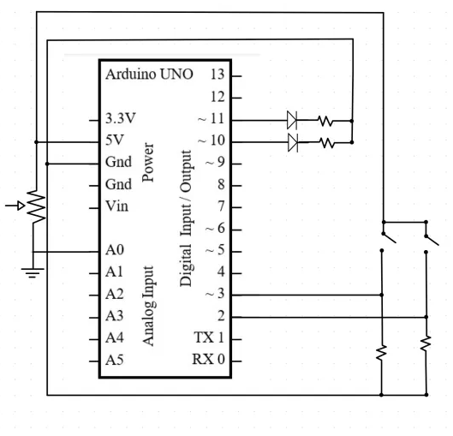

B. Program Flowchart:
Draw a flowchart of the program.
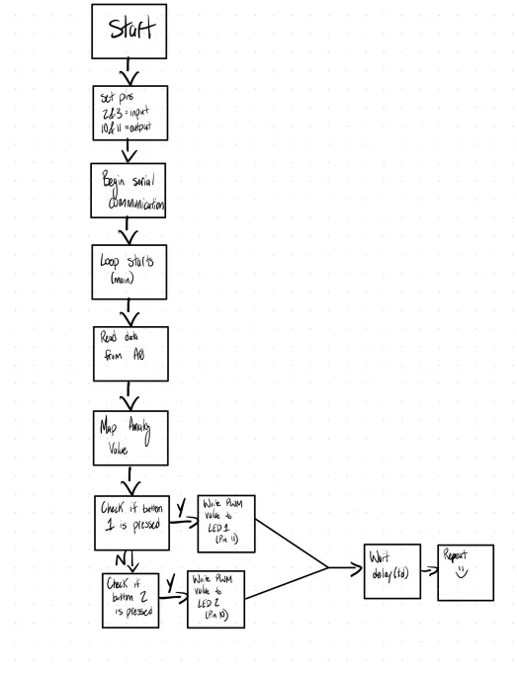

C. Arduino Source Code
Insert the Arduino Source Code into the document.
// ECE 2305 – Hardware Project 4: LED Dimmer

// Pin Definitions
const int selectLED1 = 2; // Button to select LED1
const int selectLED2 = 3; // Button to select LED2
const int potPin = A0; // Potentiometer input

const int led1 = 11; // PWM output to LED1
const int led2 = 10; // PWM output to LED2

void setup() {
pinMode(selectLED1, INPUT);
pinMode(selectLED2, INPUT);
pinMode(led1, OUTPUT);
pinMode(led2, OUTPUT);
Serial.begin(9600); // Optional for debugging
}

void loop() {
int potValue = analogRead(potPin); // Read potentiometer
int pwmValue = map(potValue, 0, 1023, 0, 255); // Map to PWM range

Serial.print("Potentiometer: ");
Serial.print(potValue);
Serial.print(" -> PWM: ");
Serial.println(pwmValue);

// Check which button is pressed
if (digitalRead(selectLED1) == HIGH) {
analogWrite(led1, pwmValue); // Update LED1 brightness
}

if (digitalRead(selectLED2) == HIGH) {
analogWrite(led2, pwmValue); // Update LED2 brightness
}

delay(50); // Small delay for smooth behavior
}

D. Demonstration Video
Record and upload a video demonstrating the operation of the circuit.
DONE
Save the document as a PDF file and submit the PDF document to Blackboard.

